MegaRAC Community Edition™
  - [Getting Started Guide]

Contents
1 Introduction 2
2 Megarac Community Edition vs Megarac OneTree 2
3 Prerequisites 3
4 Download and Build 4
4.1 AST2600EVB 4
4.2 AST2700EVB 4
4.3 Nuvoton Arbel: 4
4.4 Agilex-3 4
4.5 Agilex-5 5
5 Firmware Flashing Method 5
5.1 Dediprog 5
5.2 TFTP Flash 5
5.3 Web Flash 6
5.4 Phosphor IPMI Flash 7
6 Network Configurations 7
6.1 U-boot 7
6.2 Linux 8
6.3 Using ipmi Configure Network Settings 8
6.4 Configure Network through Web UI 8
7 BMC Debug Console 13
7.1 Minicom Configuration 13
7.2 Uboot 14
7.3 Linux 14
7.4 Uboot - Booting to BMC Linux 15
8 Supported Features 16
8.1 Generic Features 16
8.2 SOC Specific 17
8.2.1 AST2600 17
8.2.2 AST2700 17
8.2.3 Arbel 17

Introduction
This document provides information about ASPEED and Nuvoton EVB board details, build and flash using MegaRAC Community Edition™ in the OCP.
CE is our production-ready, opensource-based BMC remote management solution developed on core technology from the Linux Foundation OpenBMC project. The solution integrates state-of-the-art technologies across multiple platforms and system-on-chip (SoC) processors, enabling it to be implemented on a wide range of industry use cases. And can be enhanced with proprietary AMI IP Expansion Packs (EPs) and Silicon packs based on the proven MegaRAC firmware stack, trusted for years by leading OEMs and ODMs for its robust, secure remote server management.
For more details: https://www.ami.com/megarac/

Megarac Community Edition vs Megarac OneTree
- Megarac OneTree: Includes a complete upgrade to ASPEED SDK v11.01.
- Megarac Community Edition: Based on Megarac OneTree, but with limited features. It does not support the Enterprise Pack (EP) or Silicon Pack (Si).
Feature | Megarac Community Edition | Megarac OneTree
Core Features and Bug Fixes | ✓ | ✓
L2 Support | ✓ | ✓
Multi-platform & multi-vendor support | ✓ | ✓
Newer hardware support¹ | ✓ | ✓
Unified codebase² | ✓ | ✓
Silicon and Customer Reference Platform Support³ | △ | ✓
Regular Sync with Upstream | △ | ✓
Latest SDK Update | △ | ✓
L1 Support | ✗ | ✓
Value Add Features ⁴ | ✗ | ✓
New Technology Enablement (GPGPU) | ✗ | ✓
SLA (Bug and Security) | ✗ | ✓
Security Advisory | ✗ | ✓
Tools, Documentation and Training | ✗ | ✓
Live Tree Access | ✗ | ✓
NRE Support (Dedicated Engineering Service) | ✗ | ✓
Faster TTM | ✗ | ✓

Note:
- Includes newer BMC SoCs like AST2700 and others.
- simplifies maintenance and supports multiple SoCs/vendors from a single source tree.
- AMI support CRB’s across various silicon providers, to get list of supported CRBs on MegaRAC OneTree, contact www.ami.com
- AMI provides Expansion Packs to manage the various controllers on the host, like RAID, NIC etc. To get the list of available Expansion Packs on MegaRAC OneTree, contact www.ami.com
- △ indicates that the feature is supported, but it receives updates approximately every six months in line with the MegaRAC Community Edition release cycle from AMI.

Prerequisites
- The user should clean install Ubuntu 18.04 or later version as a build machine.
- The OpenBMC Linux Foundation (LF) source code was maintained under Git; the user must install the Git on the build machine before fetching the source code.
- Open the Linux console on the build machine and run the below command.
$ sudo apt-get install -y git build-essential libsdl1.2-dev texinfo gawk chrpath diffstat
- Install python and pip
sudo apt-get install python
sudo apt-get install python-pip
- Install git python and yaml parser
$ sudo pip install gitpython
$ sudo pip install pyyaml

Download and Build

AST2600EVB
- git clone --branch CE-AMI202607 https://github.com/ocp-hm-openbmc-opf-ami/openbmc openbmc; cd openbmc
- git clone --branch CE-AMI202607 https://github.com/ocp-hm-openbmc-opf-ami/meta-core
- git clone --branch CE-AMI202607 https://github.com/ocp-hm-openbmc-opf-ami/meta-ami
- meta-ami/github-gitlab-url.sh
- TEMPLATECONF=meta-ami/meta-evb/meta-evb-aspeed/meta-evb-ast2600/conf/templates/default . openbmc-env
- bitbake obmc-phosphor-image

AST2700EVB
- git clone --branch CE-AMI202607 https://github.com/ocp-hm-openbmc-opf-ami/openbmc openbmc; cd openbmc
- git clone --branch CE-AMI202607 https://github.com/ocp-hm-openbmc-opf-ami/meta-core
- git clone --branch CE-AMI202607 https://github.com/ocp-hm-openbmc-opf-ami/meta-ami
- meta-ami/github-gitlab-url.sh
- TEMPLATECONF=meta-ami/meta-evb/meta-evb-aspeed/meta-evb-ast2700/meta-ast2700/conf/templates/default . openbmc-env
- bitbake obmc-phosphor-image

Nuvoton Arbel:
- git clone --branch CE-AMI202607 https://github.com/ocp-hm-openbmc-opf-ami/openbmc openbmc; cd openbmc
- git clone --branch CE-AMI202607 https://github.com/ocp-hm-openbmc-opf-ami/meta-core
- git clone --branch CE-AMI202607 https://github.com/ocp-hm-openbmc-opf-ami/meta-ami
- meta-ami/github-gitlab-url.sh
- TEMPLATECONF=meta-ami/meta-evb/meta-evb-nuvoton/meta-evb-npcm845/conf/templates/default . openbmc-env
- bitbake obmc-phosphor-image

Agilex-3
- git clone --branch CE-AMI202607 https://github.com/ocp-hm-openbmc-opf-ami/openbmc openbmc; cd openbmc
- git clone --branch CE-AMI202607 https://github.com/ocp-hm-openbmc-opf-ami/meta-core
- git clone --branch CE-AMI202607 https://github.com/ocp-hm-openbmc-opf-ami/meta-ami
- git clone https://github.com/ocp-hm-openbmc-opf-ami/meta-altera.git
- meta-ami/github-gitlab-url.sh
- TEMPLATECONF=meta-altera/meta-agilex3/conf/templates/default . openbmc-env
- bitbake obmc-phosphor-image

Agilex-5
- git clone --branch CE-AMI202607 https://github.com/ocp-hm-openbmc-opf-ami/openbmc openbmc; cd openbmc
- git clone --branch CE-AMI202607 https://github.com/ocp-hm-openbmc-opf-ami/meta-core
- git clone --branch CE-AMI202607 https://github.com/ocp-hm-openbmc-opf-ami/meta-ami
- git clone https://github.com/ocp-hm-openbmc-opf-ami/meta-altera.git
- meta-ami/github-gitlab-url.sh
- TEMPLATECONF=meta-altera/meta-agilex5/conf/templates/default . openbmc-env
- bitbake obmc-phosphor-image

Firmware Flashing Method
Note:
For Dediprog and TFTP “xxx.mtd” image should be used.
For WEB Flash “xxx.mtd.tar” or “xxx.mtd.tar.all” images should be used.
“xxx” means image name.

Dediprog
Hardware Tool: DediProg* SF600 or similar tool
Software: DediProg Software latest version
The following are the steps to perform using Dediprog Software.
- Take the BMC EEPROM from the BMC socket and place it in DediProg programming socket.
- Launch the DediProg software and select SPI Device.
- Upload the firmware image file.
- Click Batch and then the flashing starts.

TFTP Flash
- Set the environment value:
Set Tftp server ip and ethaddr and get dynamic ip address
Example:
setenv serverip <IP Address>
setenv ethaddr <MAC>
setenv eth1addr <MAC>
setenv ethact <ethaddr>
dhcp

- Download image from tftp server and flash (ASPEED):
Example: AST2600
tftp 0x83000000 <image>
sf probe 0
sf update 0x83000000 0x00 <image size in bytes>
reset
Example: AST2700
tftp 0x403000000<image>
sf probe 0
sf update 0x403000000 0x00 <image size in bytes>
reset

- Download image from tftp server and flash (Nuvoton Arbel):
Example:
tftp 0x62080000 <image>
sf probe 0:0
sf update 0x62080000 0x00 <image size in bytes>
reset

- Download image from tftp server and flash (Agilex-3 & Agilex-5):
Example:
tftp 0x82000000 <image>
setexpr blkcnt ${filesize} / 0x200
mmc write 0x82000000 0 ${blkcnt}
reset

Web Flash
User can navigate to Operations à Firmware page.
Given below is the screenshot for the Firmware page.
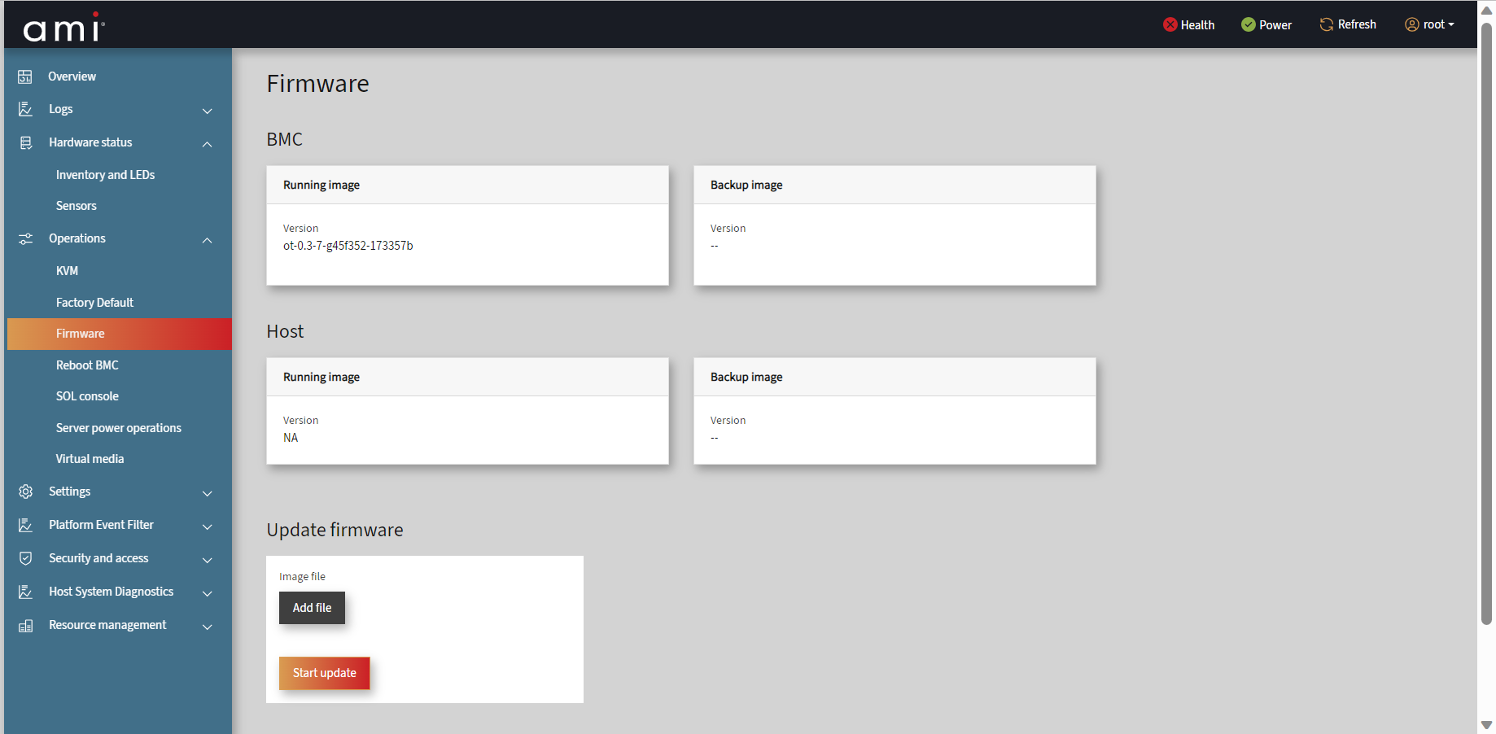
The Firmware page contains the information about following:
- BMC - It displays the version of Running image and Backup image.
- Host - It displays the version of Running image and Backup image.

Update Firmware
- Click Add file and locate the firmware file to upload based on the firmware image.
- Click Start Update and bmc will start uploading the firmware and after some time UI gets logout and BMC will reboot it.
- 5-10 minutes for the BMC to flash and reset.

Phosphor IPMI Flash
Phosphor IPMI Flash is a command line tool used to perform the in-band update of BMC firmware using OEM IPMI blob transport. Refer Phosphor IPMI Flash Tool section for more details and usage information of the tool.

Network Configurations

U-boot
ast>setenv ethaddr xx:xx:xx:xx:xx:xx
ast>setenv eth1addr xx:xx:xx:xx:xx:xx
ast>dhcp
After we get BMC IP, save the environment variables by issuing the save command.
ast>save
To learn more information about booting from uboot to BMC Linux, kindly refer tor to “BMC Debug Console: uboot – booting to Linux”.

Linux
~ # ifconfig eth0 down
~ # ifconfig eth0 hw ether xx:xx:xx:xx:xx:xx
~ # systemctl restart systemd-networkd.service

Using ipmi Configure Network Settings
# ipmitool -H <BMCIP> -U root -P 0penBmc -I lanplus lan set <channel number> macaddr <MAC>
# ipmitool -H <BMCIP> -U root -P 0penBmc -I lanplus lan set <channel number> ipsrc <static/dhcp>
# ipmitool -H <BMCIP> -U root -P 0penBmc -I lanplus lan set <channel number> ipaddr <IP>
# ipmitool -H <BMCIP> -U root -P 0penBmc -I lanplus lan set <channel number> netmask <netmask>

Configure Network through Web UI
User can navigate to Settings > Network page. Given below is the screenshot for the Network page.
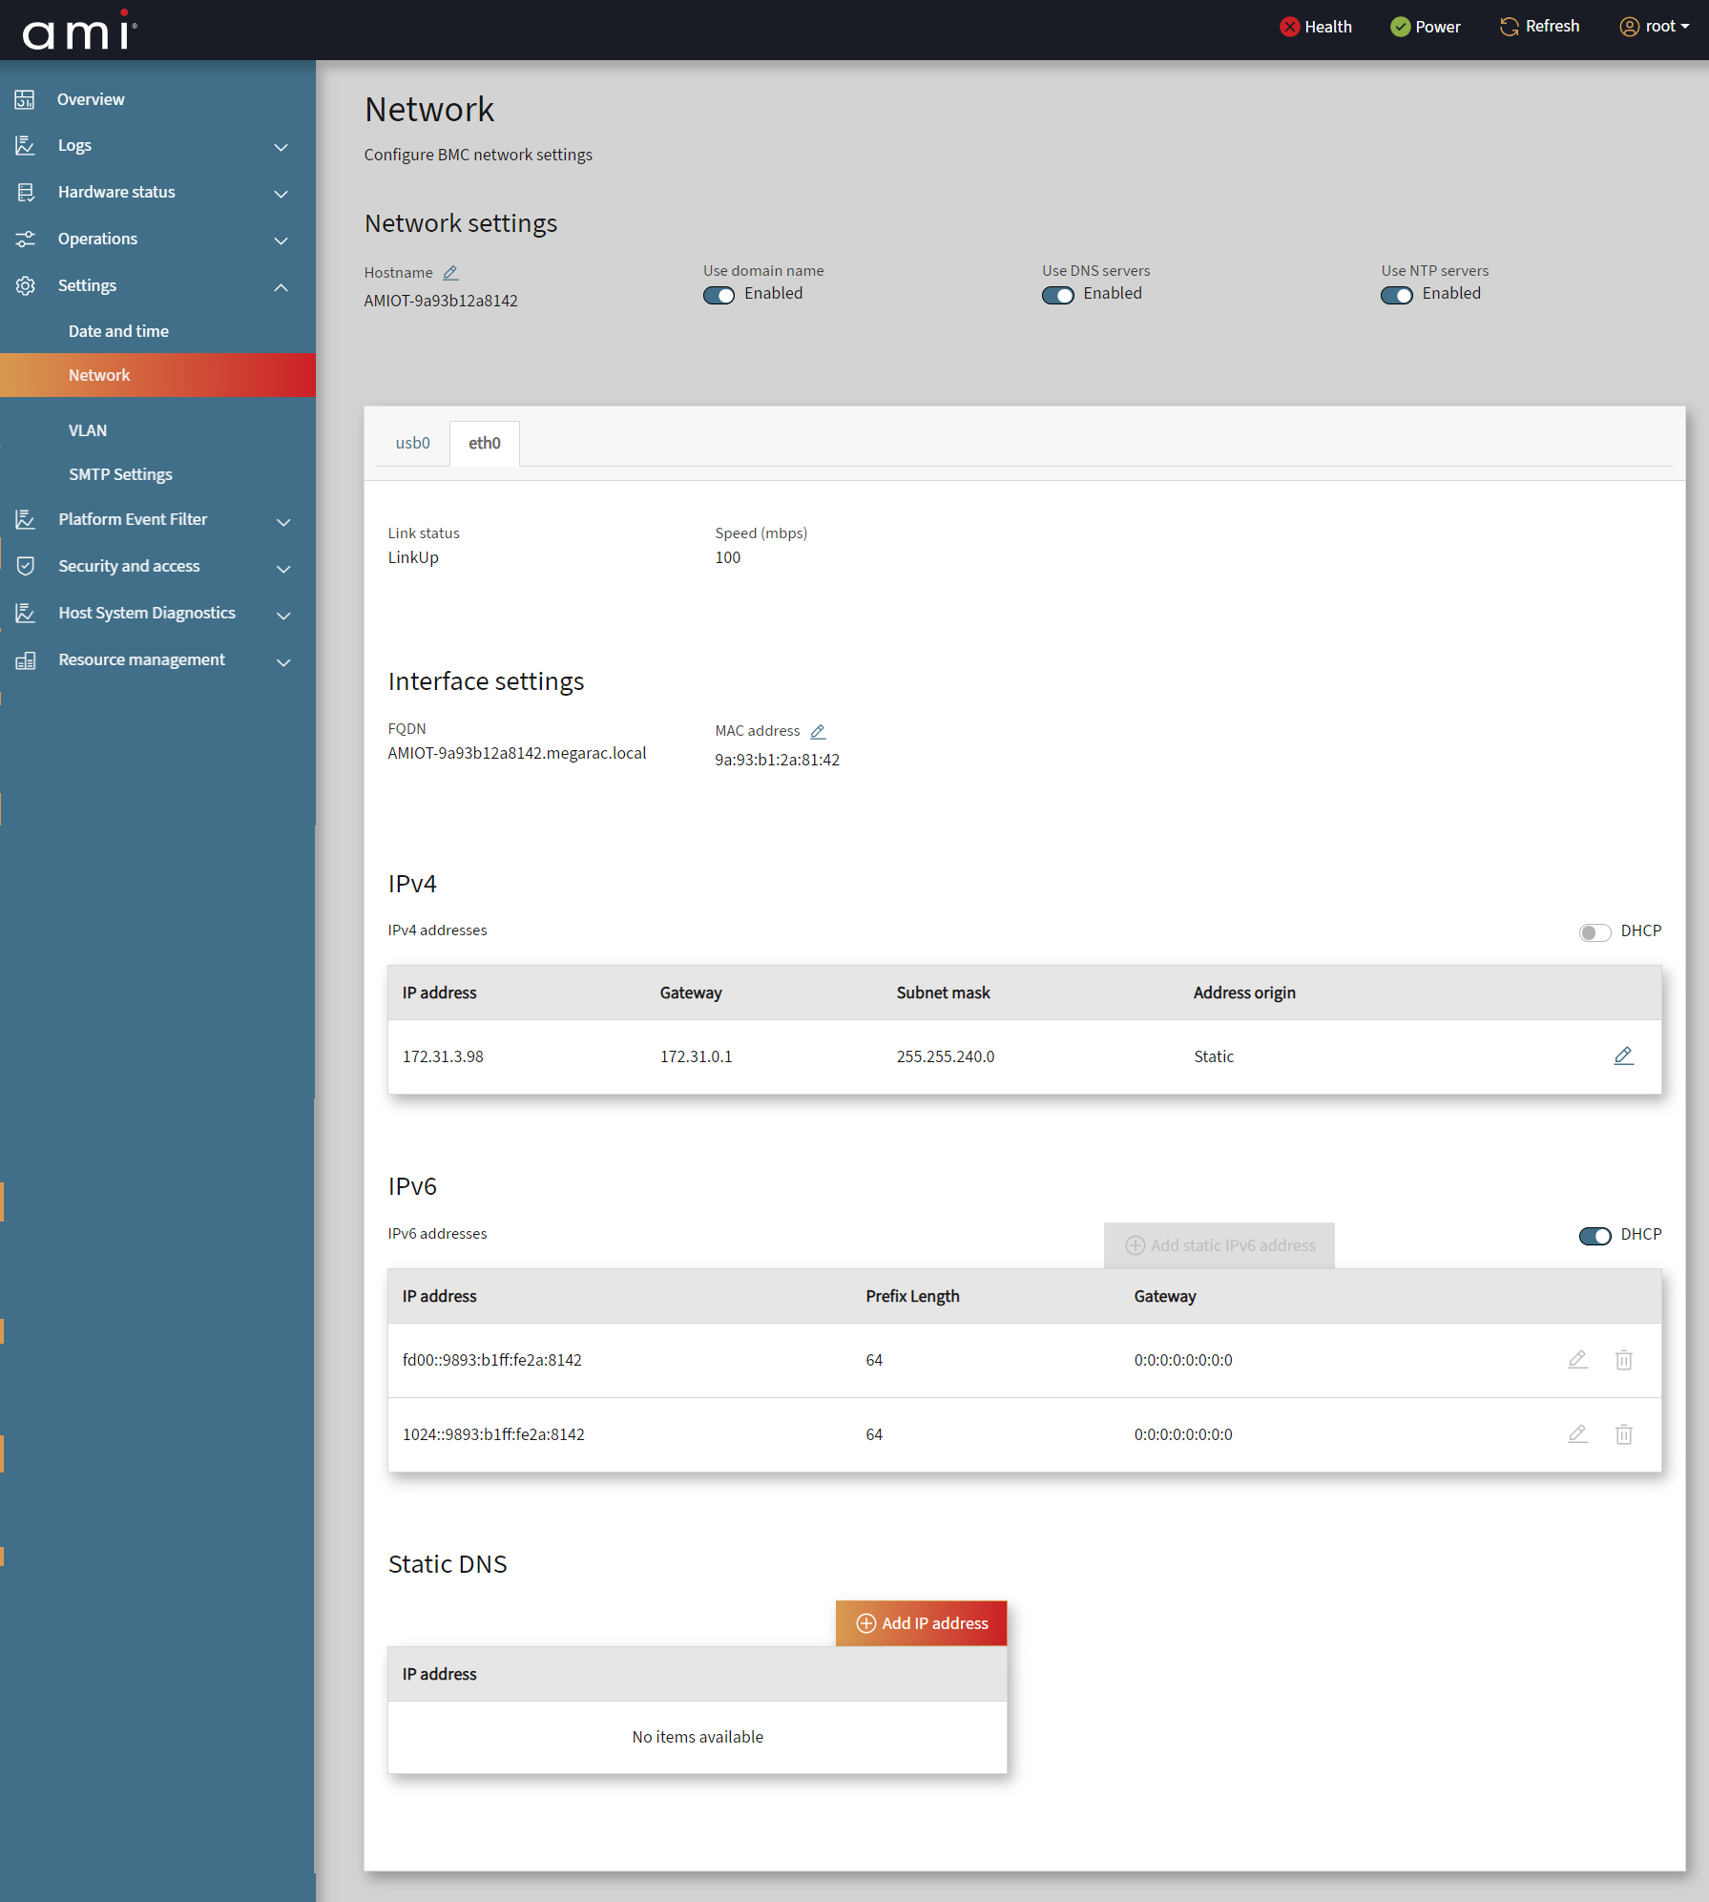
The Network page contains the information about following:
The network page helps to configure BMC network settings.
Network Settings
- Hostname – Click Edit hostname icon to add Hostname.
- Use domain name - Enable to use domain name.
- Use DNS servers - Enable to use DNS servers.
- Use NTP servers - Enable to use NTP servers.
User can Configure the BMC network setting through interfaces eth0, usb0 and usb1. By clicking the respective interfaces, it allows the user to perform the following operations:
It shows the Link status and speed (mbps).
- Interface settings:
- FQDN – It shows domain names.
- MAC address – Click Edit Mac address icon to add MAC address.
IPv4 addresses – It displays information like IP address, Gateway, Subnet mask and Address origin. And then the user can add a static IPv4 address as displayed in the screenshot below.
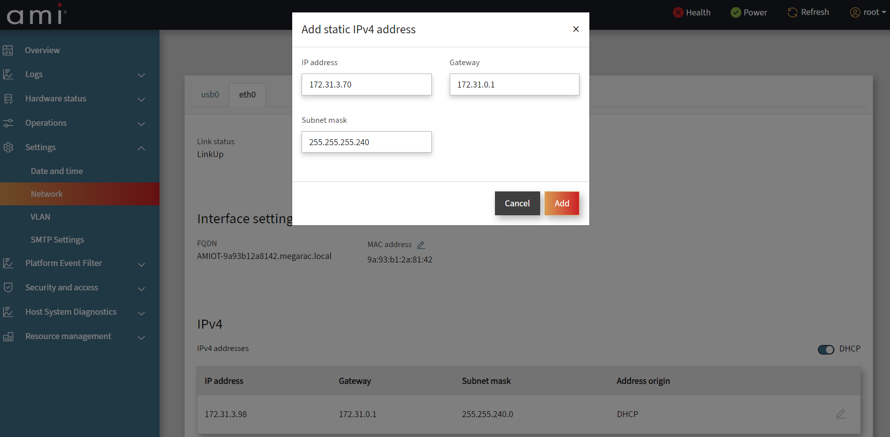
- Add static IPV4 address – Toggle DHCP in Network page or click Add static IPv4 address and enter IP address, Gateway, and Subnet mask.
- Add - Click Add to add the static IPV4 address.
- Address can be deleted or edited using the Delete or Edit icon in the right corner.
IPv6 addresses – It displays the information like IP address, Prefix Length and. Gateway. And users can add a static IPv6 address.
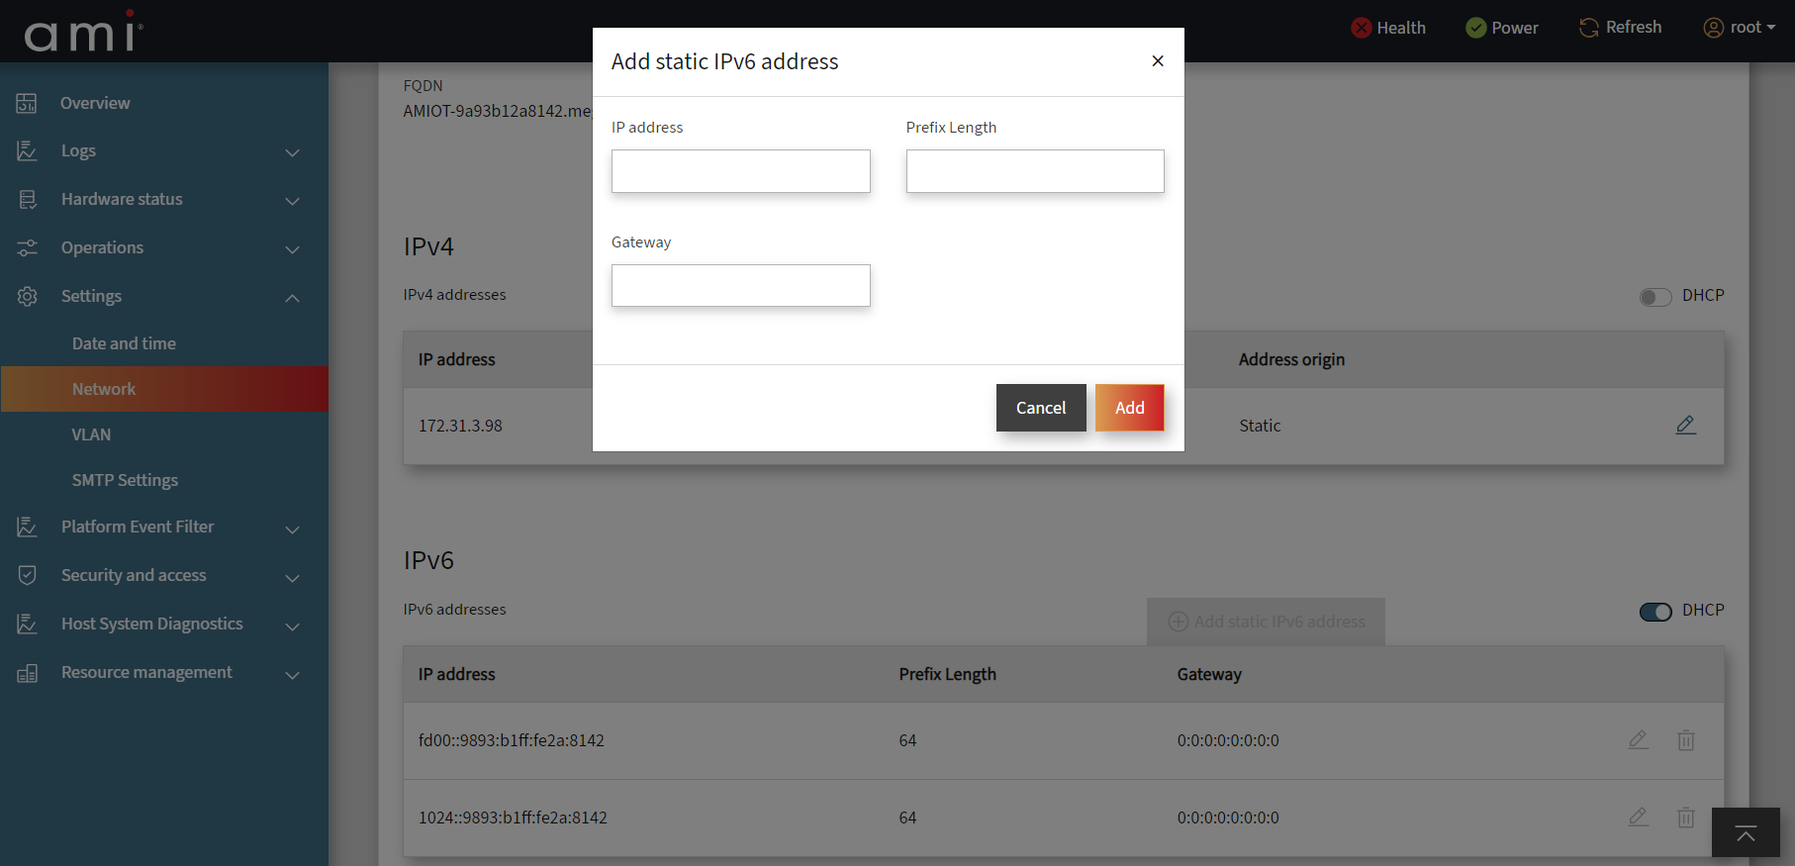
- Add static IPv6 address - Toggle DHCP in Network page or click Add static IPv6 address and enter IP address, Prefix Length and Gateway.
- Add - Click Add to add the static IPv6 address.
- Added can be deleted or edited using Delete or Edit icon in the right corner.
Static DNS - Click Add IP address, enter the Static DNS and click ADD to successfully add the Static DNS.
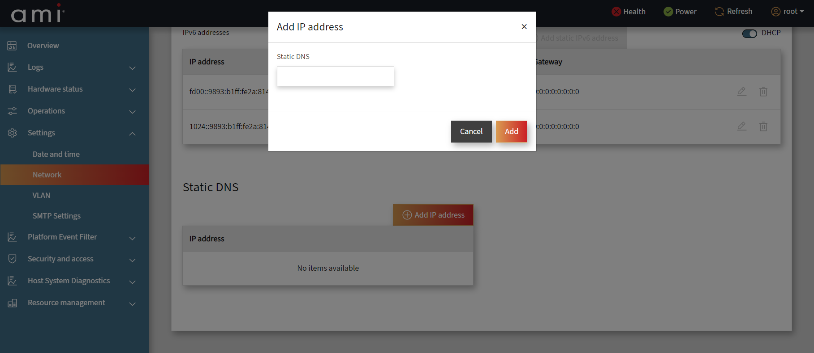
Note:
Open BMC will support only uni-cast and locally administrated MAC address.
Range:
There are 4 ranges of Locally Administered Address Ranges that can be used on a local network:
x2-xx-xx-xx-xx-xx
x6-xx-xx-xx-xx-xx
xA-xx-xx-xx-xx-xx
xE-xx-xx-xx-xx-xx
Where x can be replaced by any hex value

Establish WEB
BMC FW supports a web server based on the bmcweb implementation and webui-vue front end. This can be accessed using the BMC IP address.
The fields are explained as follows:
Username: Enter your username in this field.
Password: Enter your password in this field.
Log in: After entering the required credentials, click Log in to login to MegaRAC community edition GUI.
Once logged successfully, you will get the BMC Overview page as shown below.
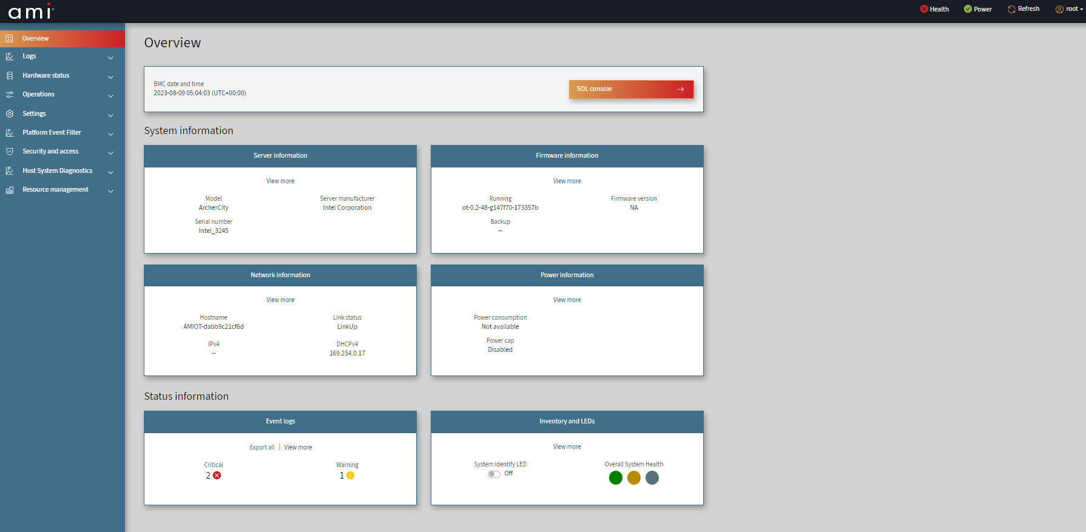
Quick buttons at the top right panel in Overview page:
- Health - Click Health will redirect to Event Logs page.
- Power - Click Power will redirect to Server power operations page.
- Refresh - It helps to refresh the current window.
- Root - Click Root -> navigate to Profile Setting page to find Profile information, Change password, Time zone. and logout which will come back to the Login page.

BMC Debug Console

Minicom Configuration
In order to get the correct BMC Debug console, users should configure the following, apart from ‘TTY to USB serial cable’ connections from server to minicom machine. Here minicom machine can be any machine where users can get access to BMC debug console.
When using Ubuntu as minicom machine,
- Open a terminal and type “dmesg | grep tty” which gives you in which tty device, the TTY to USB cable is active.
- Install ‘minicom’ if not already available. By giving “apt-get install minicom”. If you already have minicom installed, type “minicom ttyUSB<x>” in order to get the debug console.
- Press ‘Ctrl + a + o’ which will show ‘configuration’ grid. From there, traverse down to “Serial Port Setup” hit enter. The following parameters are observed.
- Press ‘A’ – and set ‘Serial Device’ with ‘/dev/ttyUSB<x>’
- Press ‘E’ – and choose 115200 8N1 as ‘Bps’
- Press ‘G’ – choose ‘Hardware Flow Control’ as ‘No’
- Press ‘H’ – choose ‘Software Flow Control’ as ‘No’
After setting all the parameters, it should look below.
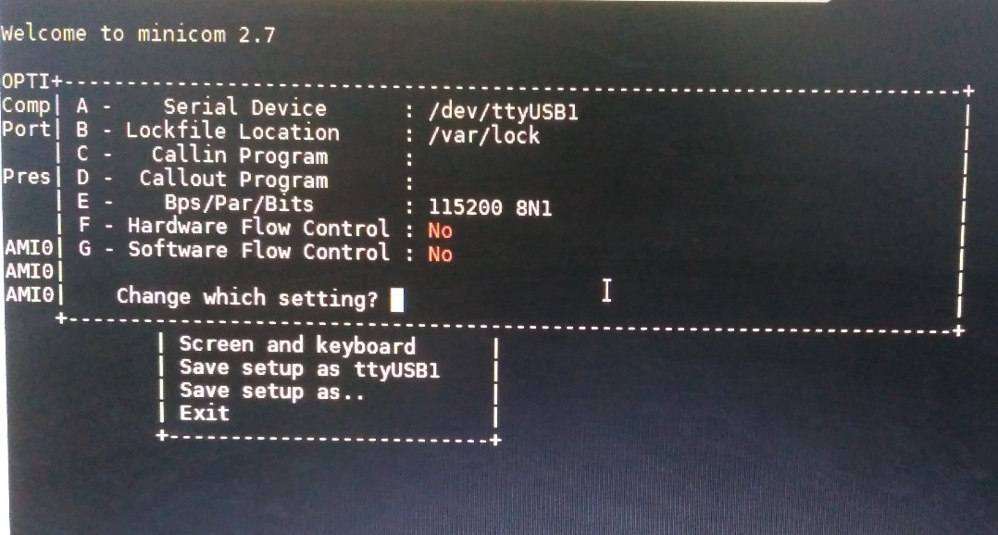
- Press ‘Enter’ after setting all the parameters, which will take you back to ‘configuration’ grid, traverse down to ‘Save Setup as ttyUSB<x>’ and save your configurations. And then ‘exit’
- Now close the minicom session by giving ‘Ctrl + a + q’ and reopening the session. After that users should have a decent BMC Debug Console.

When using Windows as Minicom Machine,
- User needs to install drivers for TTY to USB cable for the first time. The following link can be used for getting drivers.
https://learn.adafruit.com/adafruits-raspberry-pi-lesson-5-using-a-console-cable/software-installation-windows
- After successful installation of drivers, plug in the USB to minicom machine, and go to, ‘Device Manager’ -> ‘Serial COM ports’ and find out on which COM Port, the device is populated.

- Open Putty terminal chose the last section ‘Serial’ from ‘Category’. On right side, user gets following options
‘Serial line to connect to’ -> mention whatever the COM port observed from step 2.
‘Speed’ -> set as ‘115200’
‘Data bits’ -> set as ‘8’
‘Stop bits’ -> set as ‘1’
‘Parity’-> set as ‘None’
‘Flow Control’ ->set as ‘XON/XOFF’
- Hit ‘Open’ at the end to start accessing the BMC Debug Console.

Uboot
By default, auto delay is not configured when debug-tweaks is disabled. User has to enable the debug-tweaks to stop the BMC in –boot.
Uncomment EXTRA_IMAGE_FEATURES += "debug-tweaks" in build/conf/local.conf
Users can get to uboot prompt via 2 ways, mainly during AC Power ON or by issuing ‘reboot’ BMC.
- In order to get uboot prompt upon AC power on, user should press and hold the “Esc or Del” key as soon as AC power is applied, until redirected to uboot prompt.
Sometimes, users may not succeed in getting to uboot as, ‘bootdelay’ environment variable in uboot is ‘0’ initially. Which means as soon as AC power is applied to board, BMC starts booting to Linux, within ‘0’ seconds of delay or in other terms no delay. In such cases, the user should wait until BMC boots Linux completely. And follow the next method mentioned below.
- Please refer to “Section 12.3 BMC Debug Console: BMC Linux shell prompt” to get access to BMC Linux prompt.
From BMC Linux shell prompt, issue ‘reboot’ command and press and hold the “Esc or Del” key until redirected to uboot prompt.
User may optionally set ‘bootdelay’ uboot environment variable with desired delay in seconds.
This defines how many seconds of BMC booting should be delayed upon reboot or next AC cycle.
ast> set bootdelay 3; save;

Linux
Upon BMC successfully booting to Linux, the user will be asked for username and password at ‘login’ to give access to BMC Linux shell prompt. Users can use the credentials below to login.
Username: root
Password: 0penBmc

Uboot - Booting to BMC Linux
After completing required operations in uboot prompt, user should issue reset command to continue booting to BMC Linux.
ast>reset or bootm <kernel load address>
Environmental Variables for UBoot
The basic environmental variables for uboot are:
- Serverip: The server ip contains the ip of the Linux or Windows system in which tftp server is present and running. The command to set up the server ip is below.
setenv serverip <IP Address>
- Ethaddr and Eth1addr: Both variables are used for setting the mac address for the board. To set the mac address, the commands are
setenv ethaddr <MAC ADDRESS>
setenv eth1addr <MAC ADDRESS>
- Ethact: This variable is used to set up the active network interface for the board. The command is given below.
For eth0 – setenv ethact ethaddr
For eth1 – setenv ethact eth1addr
For eth2 – setenv ethact eth2addr
For eth3 – setenv ethact eth3addr

Supported Features

Generic Features
- IPMI 2.0 and DCMI
- IPMI LAN Interface
- IPMB Support
- IPv4 and IPv6
- Active Directory
- Sensor Monitoring
- FRU Support
- NTP Support
- Network Management
- mDNS and DNS Support
- Redfish Support
- Event Logging
- Firmware Update
- Web UI Support
- LDAP
- User Management
- Certificate Management
- SEL: Linear and Circular SEL Support
- Telemetry Support
- PEF and Alert Management (Email)
- Service Manager
- SSH Configuration
- Hardware Watchdog
- SNMP
- Remote syslog Support
- Session Management
- SMTP
- SDK Upgrade v11.01
- Kernel Upgrade v6.6.100
- Power restores policy
- Forgot password support
- System boot device support via KVM
- Chassis collection
- Web FRU Support
- Date, Time & NTP
- Classified the event logs into default logs
- IPMI command to support get/set SEL Time UTC offset
- Support dynamic logger display changes
- Signed Image support
- BMC Full Flash support
- KVM
- Virtual and Remote Media
- VLAN
- SDR
- Event logs
- Dumps
- Post code logs

SOC Specific

AST2600
- Dual image support
- Factory Reset
- Bonding Support
- UART Logging Support
- Preserve Configuration Support
- SOL
- RADIUS

AST2700
- SOL
- Factory Reset
- UART Logging Support
- Preserve Configuration Support
- A1 & A2 board support

Arbel
- Bonding Support
- RADIUS
- A2 and A3 board support.

